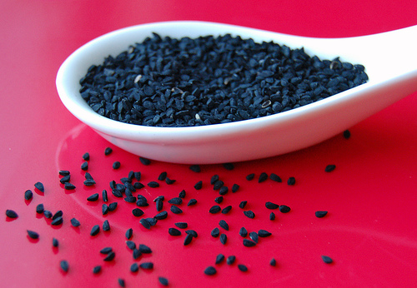
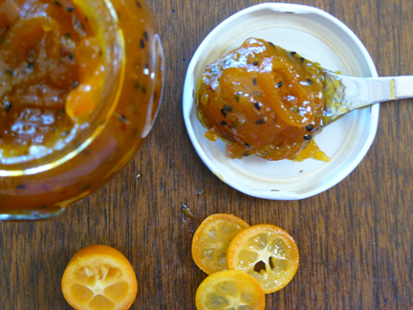
Uses: Kalonji is popularly used in Bengal as a part of panch pooran (five spice mix). It is added to vegetables, pickles, chutneys and dhall’s as flavorings. In the Middle Eastern kitchen it is spread on top of buns, breads and naan’s. It is widely used in home remedies for various ailments as it has innumerable nutrients. Kalonji contains significant proportions of vitamins, minerals, protein, carbohydrates and essential unsaturated fatty acids, namely omega3 &6, which are essential for a healthy immune system.
Health Benefits :
- Kalonji helps increase milk production in nursing mothers.
- Beta-sisterol found in the oil reduces cholesterol levels. It also contains B-Carotene, which is an essential vitamin known for its anti-cancer activity.
- Long-term supplementation with Kalonji can reduce allergic symptoms greatly
- Saponin Melathin found in the oil has strong cleaning properties and a good laxative. It destroys intestinal parasites. And promotes cleansing. It promotes the absorption of nutrients and is an appetite stimulant.
- Its consumption promotes fat metabolism, detoxification and its bronchodilating effect is protective against asthma attacks.
- Its oil has been used to treat skin conditions, such as eczema and boils.
- Kalonji oil has a high concentration of these essential fatty acids and thus when consumed provides relief from problems like high blood cholesterol, multiple sclerosis, pre-menstrual tension, tumors, arterio-thrombotic diseases and rheumatoid arthritis.

Taste : Kalonji has a pungent bitter taste and smell. It is used primarily pickles, confectionary, seasonings and liquors. Tandoori roti’s and naans are often topped with Kalonji as are Turkish buns.

Uses: Kalonji is popularly used in Bengal as a part of panch pooran (five spice mix). It is added to vegetables, pickles, chutneys and dhall’s as flavorings. In the Middle Eastern kitchen it is spread on top of buns, breads and naan’s. It is widely used in home remedies for various ailments as it has innumerable nutrients. Kalonji contains significant proportions of vitamins, minerals, protein, carbohydrates and essential unsaturated fatty acids, namely omega3 &6, which are essential for a healthy immune system
Spice Route
by Mayura Mohta

IN FLAVOR OF…
Kalonji

Kalonji is an annual flowering plant of the buttercup family. Also known as black cumin, its seeds have been used for centuries as a condiment for aromatic and medicinal properties.
- Botanical Name - Nigella sativa
- Family name- Ranunculaceae
- Common name- Kaloonji
- Part used – Seeds

Different Names of Kalonji : Fennel flower, Roman coriander, blackseed or black caraway, black cumin, onion seed, roman coriander, carvi (French), schwarzkummel (German), kalonji (Hindi/Urdu), kezah (Hebrew) chernushka (Russian), corek-otu (Turkish), habbat-albarakah or habbatus-sauda (Arabic) siyah daneh (Persian) etc. In India, Assamese call it kaljeera or kolajeera or Bengali kalo jeeray and in south Indian language Kannada it is called "Krishna Jeerige".

Origin : Kalonji is an herbal bushy that grows through out India, Bangladesh and other Eastern countries. Originally from Turkey and Italy, the physicians brought this medicinal plant to India. It is consumed a lot in Middle East and Southeast Asia.
Taste : Kalonji has a pungent bitter taste and smell. It is used primarily pickles, confectionary, seasonings and liquors. Tandoori roti’s and naans are often topped with Kalonji as are Turkish buns.

Origin : Kalonji is an herbal bushy that grows through out India, Bangladesh and other Eastern countries. Originally from Turkey and Italy, the physicians brought this medicinal plant to India. It is consumed a lot in Middle East and Southeast Asia.

Taste : Kalonji has a pungent bitter taste and smell. It is used primarily pickles, confectionary, seasonings and liquors. Tandoori roti’s and naans are often topped with Kalonji as are Turkish buns.

Uses: Kalonji is popularly used in Bengal as a part of panch pooran (five spice mix). It is added to vegetables, pickles, chutneys and dhall’s as flavorings. In the Middle Eastern kitchen it is spread on top of buns, breads and naan’s. It is widely used in home remedies for various ailments as it has innumerable nutrients. Kalonji contains significant proportions of vitamins, minerals, protein, carbohydrates and essential unsaturated fatty acids, namely omega3 &6, which are essential for a healthy immune system.

Health Benefits :

- Kalonji helps increase milk production in nursing mothers.

- Beta-sisterol found in the oil reduces cholesterol levels. It also contains B-Carotene, which is an essential vitamin known for its anti-cancer activity.

- Long-term supplementation with Kalonji can reduce allergic symptoms greatly

- Saponin Melathin found in the oil has strong cleaning properties and a good laxative. It destroys intestinal parasites. And promotes cleansing. It promotes the absorption of nutrients and is an appetite stimulant.

- Its consumption promotes fat metabolism, detoxification and its bronchodilating effect is protective against asthma attacks.

Its oil has been used to treat skin conditions, such as eczema and boils.

- Kalonji oil has a high concentration of these essential fatty acids and thus when consumed provides relief from problems like high blood cholesterol, multiple sclerosis, pre-menstrual tension, tumors, arterio-thrombotic diseases and rheumatoid arthritis.

TOP TIP :
Kalonji reduces Hair Loss & Premature Greying.
Scrub the scalp thoroughly with lemon, leave it for 15 minutes & shampoo & dry with thereafter apply kalonji oil to whole scalp, continue for a 6 weeks.

Recipe : Kalonji Mango chutney

Ingredients

2.5 cups raw green cooking mangoes peeled and shredded
1-tablespoon ginger, julienned
2 tablespoons black raisins
1-teaspoon chili powder
2-tablespoon virgin olive oil
2-teaspoon kalonji
1 cup crushed jaggery
2 dry red Kashmiri chilies
2 teaspoons salt

Method
Heat olive oil on medium heat in a wok. Now add the Kalonji and dry red chilies and stir for a few seconds. Now add the raisins and when they plump up add the rest of the ingredients stir well and cook till soft. When the mix comes to a boil lower the heat, cover and let it simmer for 10-15 minutes. Cool and serve.

TOP TIP :
Kalonji reduces Hair Loss & Premature Greying.
Scrub the scalp thoroughly with lemon, leave it for 15 minutes & shampoo & dry with thereafter apply kalonji oil to whole scalp, continue for a 6 weeks.

